**Strawberry Street Clothing**

**Color Pallete:**

* # EB455F
* # FCFFE7
* # BAD7E9
* # 2B3467

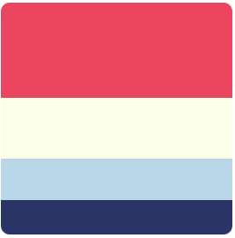

**Font Style:**

**Lato**

**Link:**

<link rel="preconnect" href="https://fonts.googleapis.com"><link rel="preconnect" href="https://fonts.gstatic.com" crossorigin>

<link href="https://fonts.googleapis.com/css2?family=Lato:wght@300;400;700;900&display= swap" rel="stylesheet">

**Style:**

<style> @import url('https://fonts.googleapis.com/css2?family=Lato:wght@300;400;700;900&display=sw ap'); </style>

**CSS**

font-family: 'Lato', sans-serif;

**Navigation:**

* Home(Logo)
* Dropdown Buttons
  + Mens
    - All Tops
    - Outwear
    - Sportwear
    - Bottoms
  + Womens
    - All Tops
    - HomeWear
    - Dresses
    - Outwear
    - Bottoms
* Best Seller

**ICONS**

**Log IN**

**Search**

**Cart**